|  |
| --- |
| **Project: Admission Office Software** |
| **User Guide** |
|  |
| This project aims at providing PKFokam Institute of Excellence with a Software to support the management its academic affairsy |
|  |
| **Realized by: Mr. Herman Mekontso** |
| **Lecturer CS/IT – PKFokam Institute of Excellence – RC Engineer** |
|  |



Table of contents

LIST OF FIGURES 3

1 – PROJECT OVERVIEW 5

1.1 – Purpose of the project 5

1.2 – Modular decomposition of the project 5

1.2.1 Students and staff management module 5

1.2.2 Grades management and transcripts generation 5

1.2.3 Programs management 6

1.2.4 Management of mails and missions 6

1.2.5 Attendance management 6

2. CURRENT STATUS OF THE PROJECT 6

3. USER MANUAL 7

3.1. Starting the application 7

3.2. Student Management 8

3.2.1. Add a new student 8

3.2.2. Modify an existing student 10

3.2.3. Handling the student life through the student personal space 11

3.3. Course Management 16

3.3.1. Add a new course 16

3.3.2. Searching and viewing a course details 17

3.3.3. Modify an existing course 18

3.3.4. Opening and closing a course for a given semester 18

3.4. Program Management 19

3.4.1. Add or edit a program 20

3.4.2. Add, modify and remove a course in program 21

3.5. Faculty Management 23

3.6. Staff Management 24

3.7. Grade Management 26

3.7.1. Registering or modifying end of semester final grades 26

3.7.2. Handling the other grades 26

3.8. Course Scheduling 27

3.8.1. Create a new schedule 28

3.8.2. Update a course schedule 28

3.8.3. Duplicate a schedule 29

3.8.4. Mark Students Attendance 29

3.9. Administration and configuration of the Software 30

3.9.1 Department management 30

3.9.2. Semester Operations 32

# LIST OF FIGURES

Figure 1: Lunching PKFokam Admission Office software. 7

Figure 2: Admission Office Login Form 7

Figure 3: Admission Office Home Page 8

Figure 4: Add a New Student Form 9

Figure 5: Search and display Student details 9

Figure 6: Edit a Student 10

Figure 7: Error Update 10

Figure 8: Student Personal space overview 11

Figure 9: Manage Courses Taken 11

Figure 10: Select or remove student courses 12

Figure 11: Student Course Selected 12

Figure 12: Student Registration Form 13

Figure 13: Student Grade 13

Figure 14: Student attendance statistics 14

Figure 15: Student Progression 14

Figure 16: Transcript Generation 15

Figure 17: Student transcript 15

Figure 18: Add a new course 16

Figure 19: Add a course pre requisite 17

Figure 20: Course Details 17

Figure 21: Update a Course 18

Figure 22: Course opening interface 18

Figure 23: Open a Course 19

Figure 24: Update an Opening 19

Figure 25: Home Programs Management 20

Figure 26: Add a new Program 20

Figure 27: Update a program 21

Figure 28: Add a Course to a Program 21

Figure 29: Update a Program Course 22

Figure 30: Faculty Management 23

Figure 31: Faculty Details 23

Figure 32: Create a new faculty 24

Figure 33: Update a Faculty 24

Figure 34: Search and display a Staff 25

Figure 35: Create a new Staff 25

Figure 36: Update an existing staff 25

Figure 37: Final Grade Registration 26

Figure 38: Other Grade Management 27

Figure 39: Attendance Management Home 27

Figure 40: Create a new Schedule 28

Figure 41: Update a Course Schedule 28

Figure 42: Marking Students Attendance 29

Figure 43: Attendance List Display 30

Figure 44: Configuration and Administration Tab 30

Figure 45: Create a New Department 31

Figure 46: Modify an Existing Department 31

Figure 47: Other Operations on Departments 32

Figure 48: Selecting a Semester for End of Sem Operations 32

Figure 49: List of students of a Semester 33

Figure 50: Print Student List per Semester 33

Figure 51: Getting the list of courses offered for a given program 34

Figure 52: Printing the list of Courses Opened a Given Semester for a Given Program 34

Figure 53: Start and End of Semester Operations 35

Figure 54: Jury Results Generation 35

# 1 – PROJECT OVERVIEW

## 1.1 – Purpose of the project

The aim of this project is to provide admission officers of a University with a tool which assists them in their daily tasks. In effect, having noticed the number and the diversity of responsibilities entrusted to these people, they absolutely need to be supported by automated tools in order to be efficient. Daily activities of admission officers can be grouped into 5 categories:

* The management of students and staff;
* The management of grades and results, and transcript generation;
* The management of programs;
* The management of attendances;
* The management of mails and missions.

The purpose of this project is to provide a tool which will support admission officers in their daily tasks.

## 1.2 – Modular decomposition of the project

From the previous section, we can infer that our software will consist of 5 main modules.

### 1.2.1 Students and staff management module

This module can be divided into two sub modules: student management and staff management. The student management sub module allows end users to:

* keep track of the information about students from the time of their registration to when they leave the school;
* Get at any time detailed and personal information, as well as a history of its progression of each student;
* Get the disciplinary status of any students (statistics);
* Report on the students registered per program and per semester (statistics)
* The staff of a University can be divided into two categories: the teaching staff, and the administrative and supporting staff. Through this sub module an end user can:
* Create, update, or modify information on any staff. The option to delete a staff is not available because it is a dangerous operation;
* Assign to or remove courses from lecturers;
* Manage top level staff such as Head of departments, Academic Affair Officers, Deans, and the DAFF;
* Get the list of courses taught by a given lecturer a given semester (optional).

### 1.2.2 Grades management and transcripts generation

Grade management includes the management of course. It is through this module that courses are registered and managed. Then this module is also used to register grades, produce transcripts, and generate summaries of grades anytime needed. This module will also allow getting relevant statistics concerning grades. In short, this module can be split in four sub modules:

* Course management: includes the creation, the update, the deletion and the consultation of the details of a course;
* Grade management: includes the assignment of a grade a student got to a test set for a given course, update, delete, or see details about the grade;
* Transcript generation: generating student transcript anytime;
* Reporting: reports of all kind will be generated from this module, going from transcripts to final results of the year and end of semester jury.

### 1.2.3 Programs management

Universities offer many programs. This module offers the end user the ability to manage different programs of the University. The operations that can be carried out in this module include:

* Create a new program or updating information on a given program;
* Add / Update / Remove a course to a program;
* Get the list of courses of a program (reporting);
* Get the list of students registered in a program a given semester (reporting);

### 1.2.4 Management of mails and missions

A lot of mails are sent from and received by our University and need to be organized archived. In addition to that, staffs often carry out missions. Therefore, there is a need to provide a support for the organization and the follow up of those missions. Considering the fact that the operations carried out here are very manual-based, we do not for the moment provide the software with this module.

### 1.2.5 Attendance management

Discipline is a key factor of success in a University like ours. So managing student’s and lecturer’s attendance is a relevant matter. This module will allow the admission officer to:

* Schedule regular classes, labs and catch ups;
* Generate the attendance forms;
* Mark students’ presence;
* keep track of attendances;
* generate statistics and graphs of presence and participation.

# 2. CURRENT STATUS OF THE PROJECT

The software has been developed and deployed at the PKFokam Institute of Excellence admission office. It’s being used with satisfactory results. The present document includes a user manual to guide end users throughout their journey with the software.

# 3. USER MANUAL

## 3.1. Starting the application

To start the PKFokam Management Software, locate the application icon on your desktop and double click it as shown in figure 1.

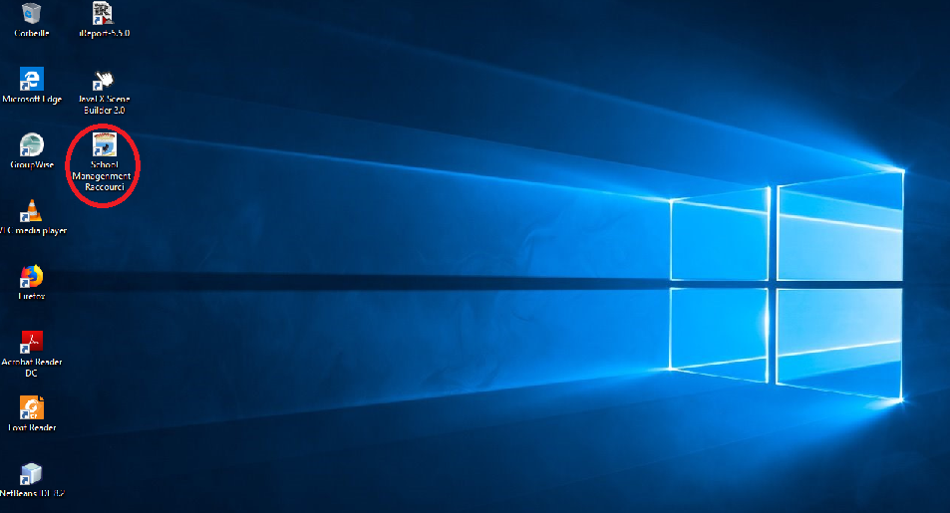

Figure 1: Lunching PKFokam Admission Office software.

Then the login page shows up and you need to enter the correct credentials to open the software. Figure 2 shows what the login page looks like. If the login and or the password is not correct, the user is displayed an error message and an invitation to try again.

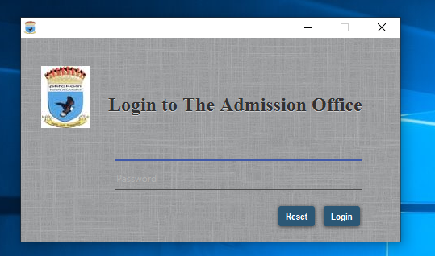

Figure 2: Admission Office Login Form

Once the user enters correct credentials, the home page shown on figure 3 is displayed.

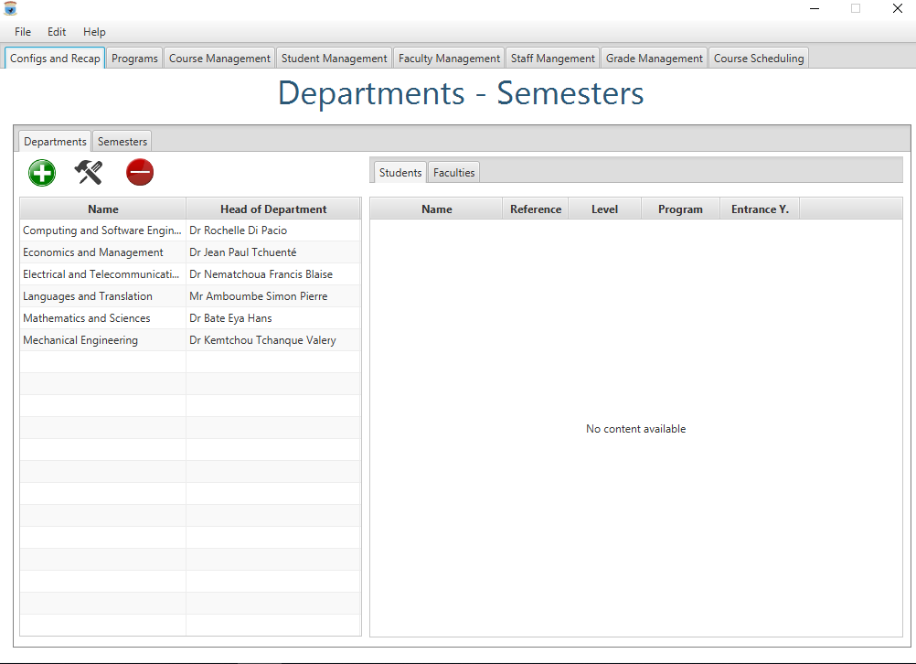

Figure 3: Admission Office Home Page

Once the end user is connected, he or she can continue to perform any of the operations mentioned in the project overview. From this home page, you can navigate through the different modules by selecting the corresponding tabs. We will go through these operations module per module.

## 3.2. Student Management

Student Management module includes:

* Add a new student;
* Edit a student to modify his personal information;
* Handling the student life through the student personal space.

### 3.2.1. Add a new student

Select the tab “Student Management” and then click on the button “New Student”. The form on figure 4 will show up for you to enter the student’s information. You should enter all the mandatory fields. You should enter the correct email format, the correct phone number format. Concerning the photo, it should be a passport photo size picture, whose maximum size at the time being is fixed to 100 x 100 pixels. After entering the information click on “save” to save the student or on “cancel” to cancel the operation. If no picture is selected, a default one will be assign to the student.

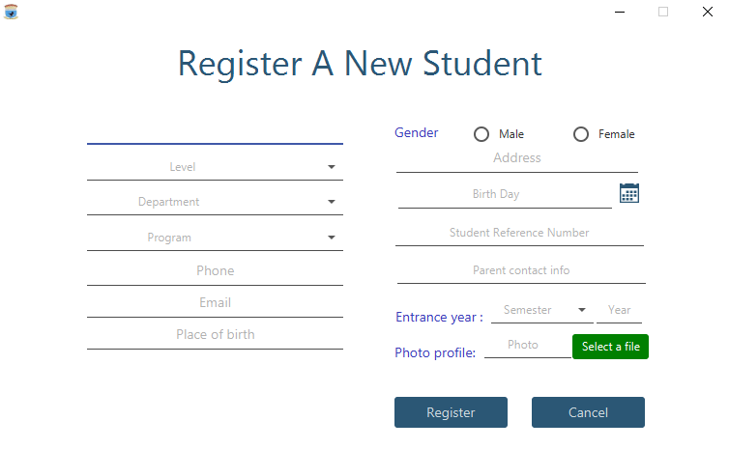

Figure 4: Add a New Student Form

When you click on save, the new student is added to the system and the table view displaying the list of students is automatically updated. You can find the added student by typing his name (or a part of his name) in the search text field. The table view will be filtered to display the searched student. You can select this last one to see on the right panel detailed information on the student. Figure 5 illustrates this.

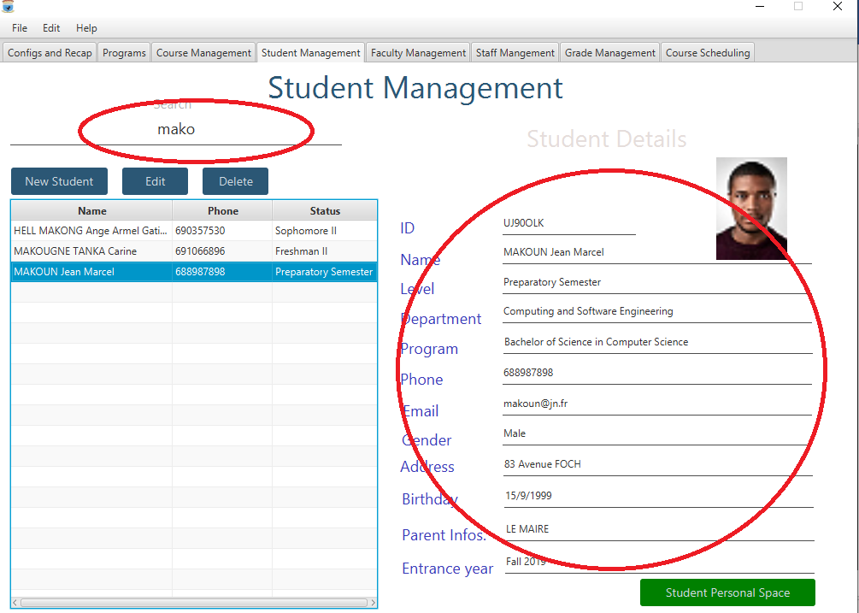

Figure 5: Search and display Student details

Note the green button that will lead you to the student’s personal space.

### 3.2.2. Modify an existing student

This functionality allows an end user to modify personal information of a given student. To complete this, proceed as follows:

* Search the student either by scrolling through the students table view or by typing the student name or a part of it in the search zone;
* Click on the row representing that student and then on the button “edit” on top of the table view. Then the windows shown in figure 6 is displayed, the user modifies the personal information of the student and then click on the button “save” to save them or on the button cancel to cancel the modification;

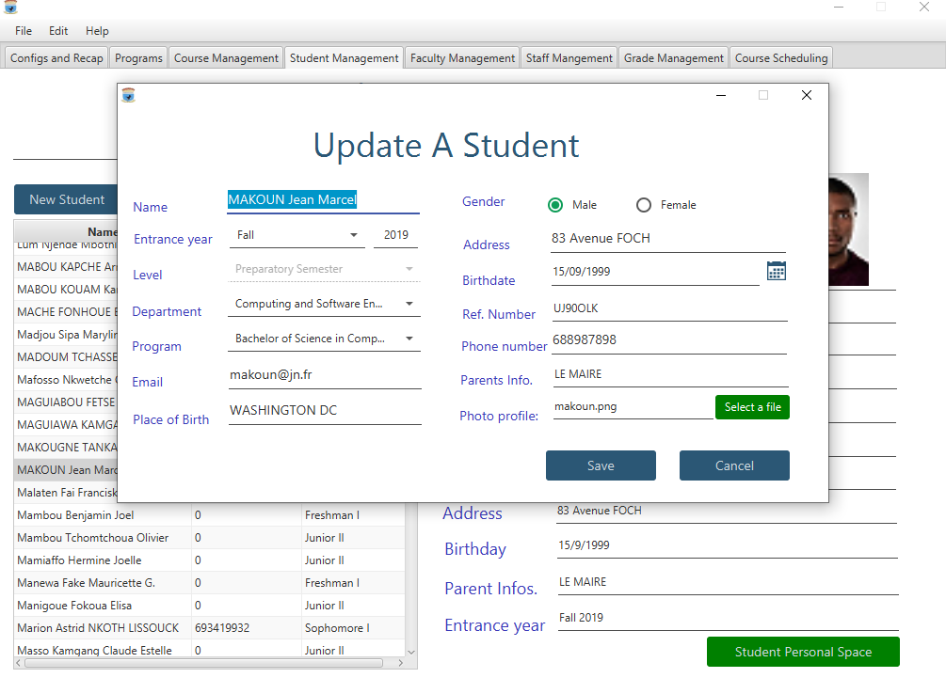

Figure 6: Edit a Student

* If no student is selected before the click on the button “edit”, he will be displayed an error message as shown in figure 7.

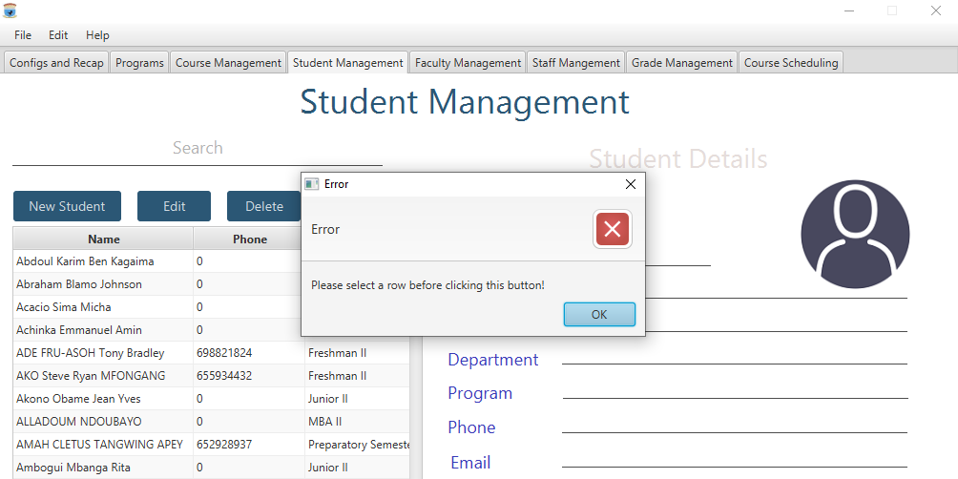

Figure 7: Error Update

### 3.2.3. Handling the student life through the student personal space

When the details on a students are displayed on the right panel, you have at the bottom a green button entitled “Student personal Space”. Click on that button to go to the student’s personal space. After doing so, the window shown in figure 8 will be displayed.

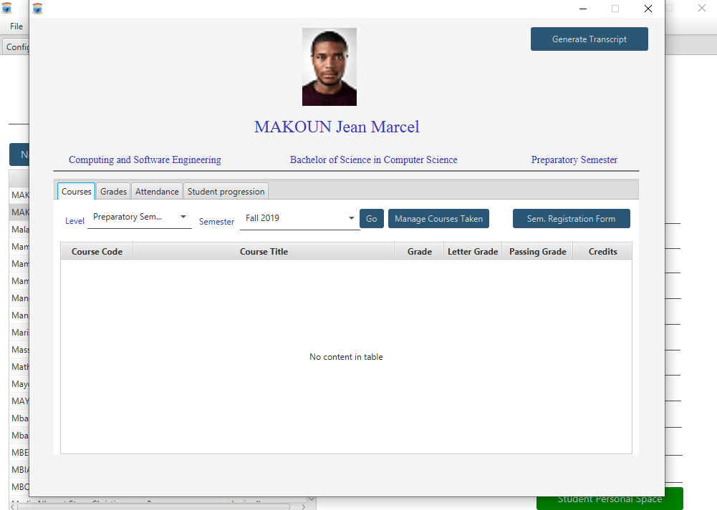

Figure 8: Student Personal space overview

When you open the student’s personal space, you have 4 tags from which you can manage and get all the information and statistics on a given student. In addition to all this, you have the top button to generate a student’s transcript at any time.

#### The Courses tag

Through this tag you can handle the courses taken by a student. By handling, we mean adding or removing the courses he takes a semester. To do that, click on “Manage Course Taken”.

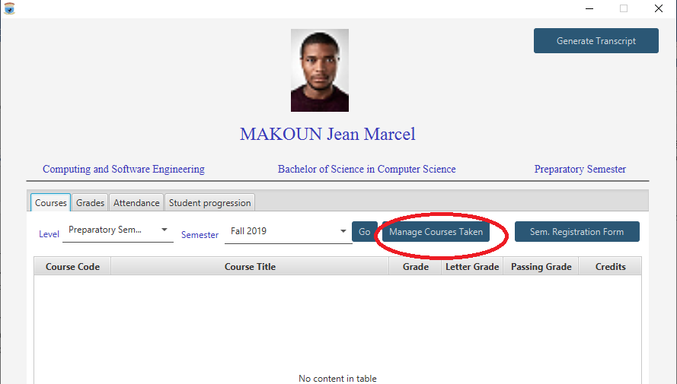

Figure 9: Manage Courses Taken

When you click on “Manage Course Taken” the window in figure 10 is displayed from which courses can be added to or removed from the student.

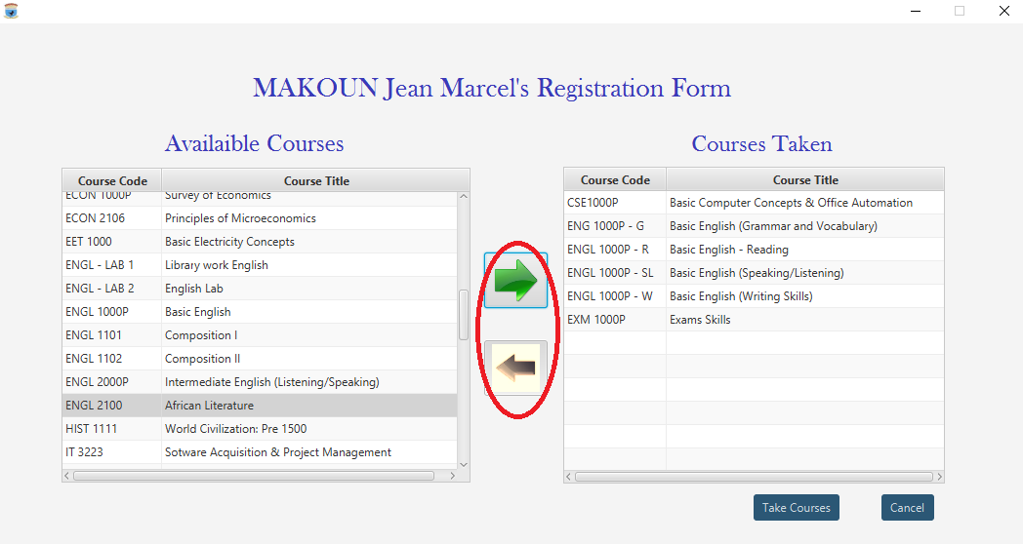

Figure 10: Select or remove student courses

Click on cancel to cancel the operation or to “Take Courses” to validate the operation that you have just performed. You will get the window of figure 11.

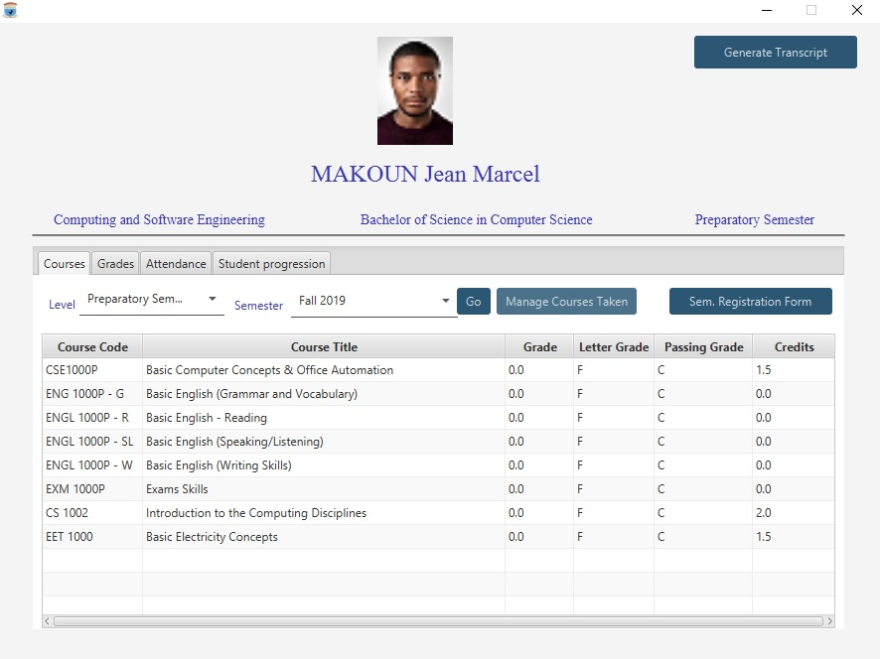

Figure 11: Student Course Selected

It should be noted that you can also from this tag, get the list of courses taken by a student in one of the previous semester, as well as the grades he or she got. From this window, you can print the student registration form, by clicking on the button “Sem. Registration Form”. The window of figure 12 will be displayed.

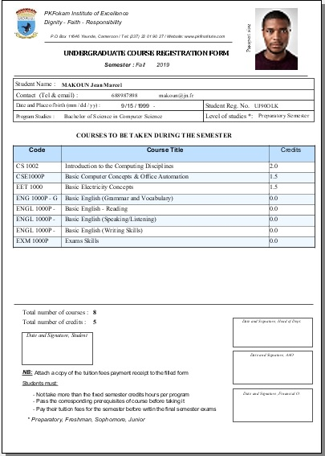

Figure 12: Student Registration Form

#### The Grades tag

You also have the grade tabs for having the grades as shown in figure 13.

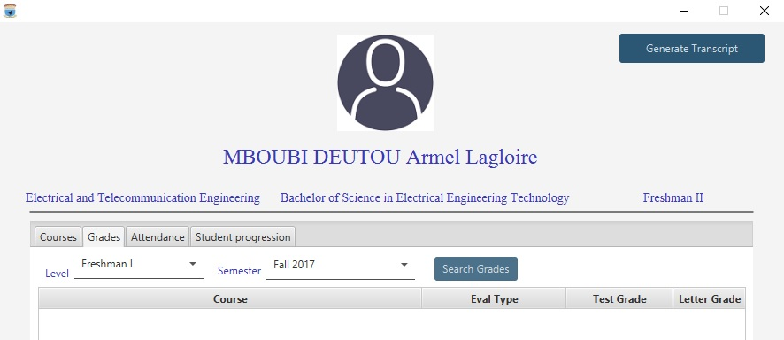

Figure 13: Student Grade

#### The Attendance tag

The attendance tag allows to get the disciplinary information and statistics on a student, for a given course, at a given period or for all the courses at the same time as shown in figure 14.

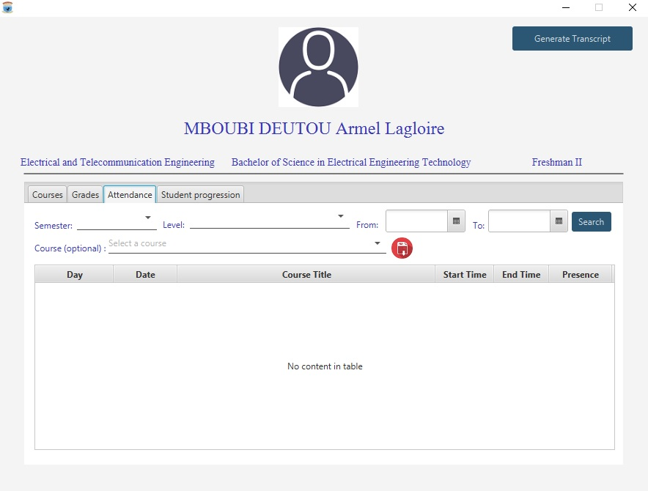

Figure 14: Student attendance statistics

#### The Student Progression tag

The end use can handle the student progression through the window of figure 15.

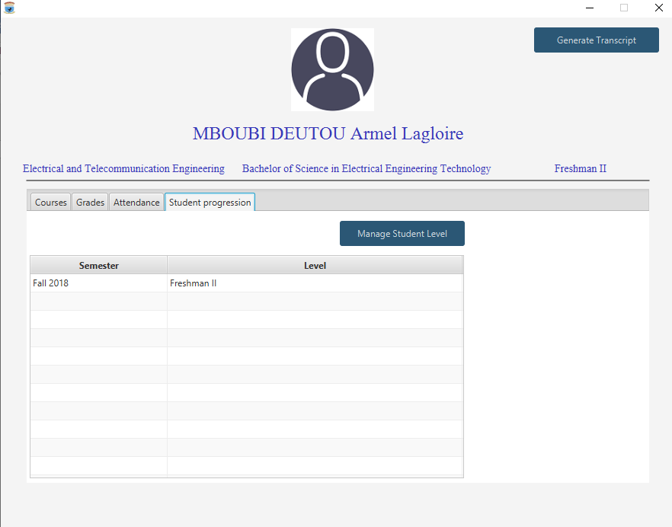

Figure 15: Student Progression

#### Transcript Generation

Through the student space window, the end user can generate a student transcript by clicking on the button “Generate Transcript” at the right most top of the window as shown in figure 16.

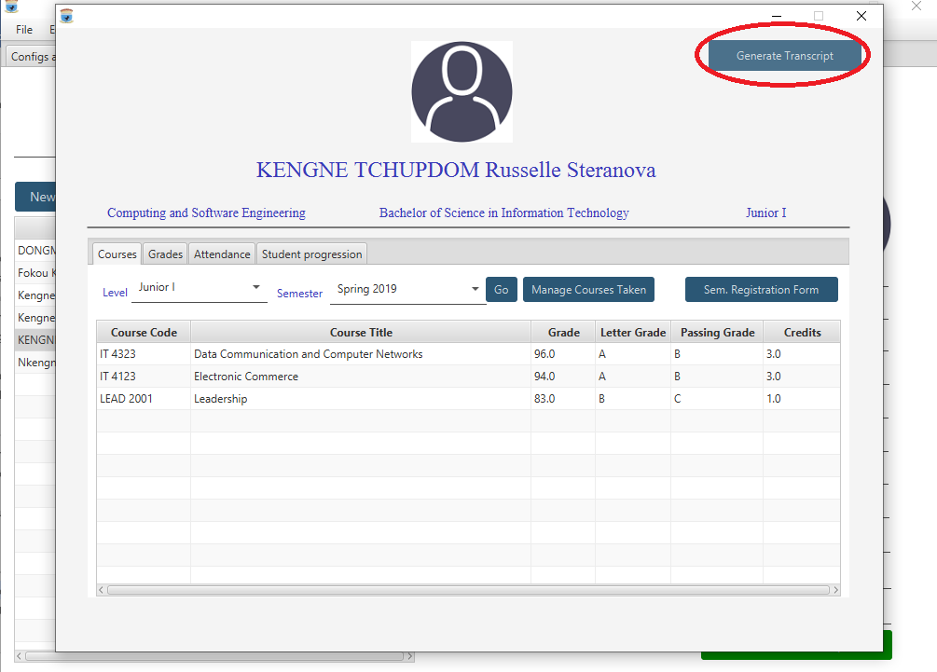

Figure 16: Transcript Generation

When you click on “Generate Transcript” the student transcript is displayed and can be therefore saved or printed as shown in figure 17.

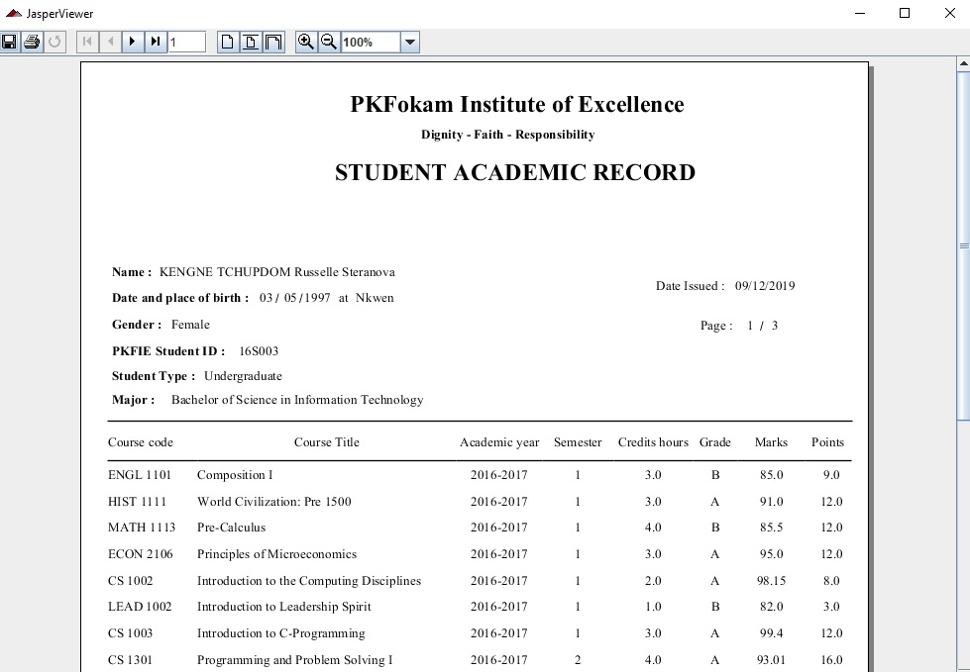

Figure 17: Student transcript

After you are done with the student personal space you can close the corresponding window to proceed with the other operations, though they were not blocked.

## 3.3. Course Management

You have the “Course Management” tag on the main window, that when open will enable you to perform the following operations concerning courses:

* Adding a new course;
* Searching and viewing course details;
* Modifying an existing course;
* Opening and closing a course for a given semester.

### 3.3.1. Add a new course

To add a new course, click on the tab “Course Management”, then click on “New Course. This opens the window shown in figure 18

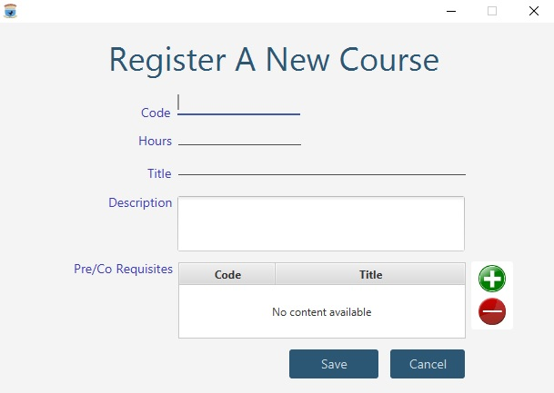

Figure 18: Add a new course

When this windows opens, the end user should enter the course characteristics. The following fields are mandatory. Codes are unique. If the end user enters an existing course code, an error message similar to the preceding error messages is displayed. The end user can then enter a new code or cancel the operation. The other not mandatory fields can be left empty and completed later. A course might have some prerequisites or co requisites. These last one can be added or removed. To remove a pre requisite or a co requisite, select the course from the pre requisite, co requisite course and click on the “remove” button on the right to remove it. If the end user wishes to add some prerequisites, he or she click on the add button on the right. The following window (Figure 19) displays to add a new pre or co requisite.

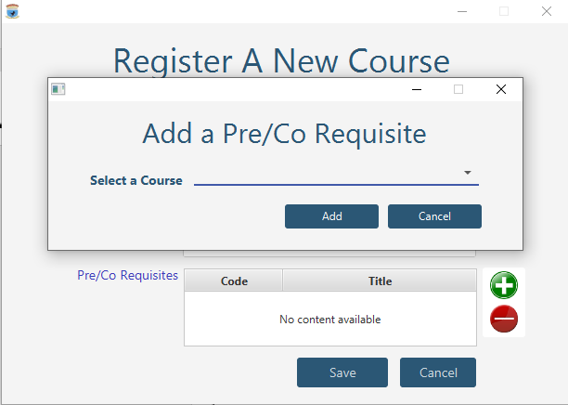

Figure 19: Add a course pre requisite

Once the end user enters the course information and pre or co requisites, they can save by clicking on the button “Save” or cancel the operation by clicking on the button “Cancel”. You can therefore see the details of the newly created course as explained in the next section.

### 3.3.2. Searching and viewing a course details

To search a course, type on the search zone the code or the title of the course or just a part of it. When you identify the line on the table view representing the course and click on it. The details are just displayed at the right as illustrated in figure 20.

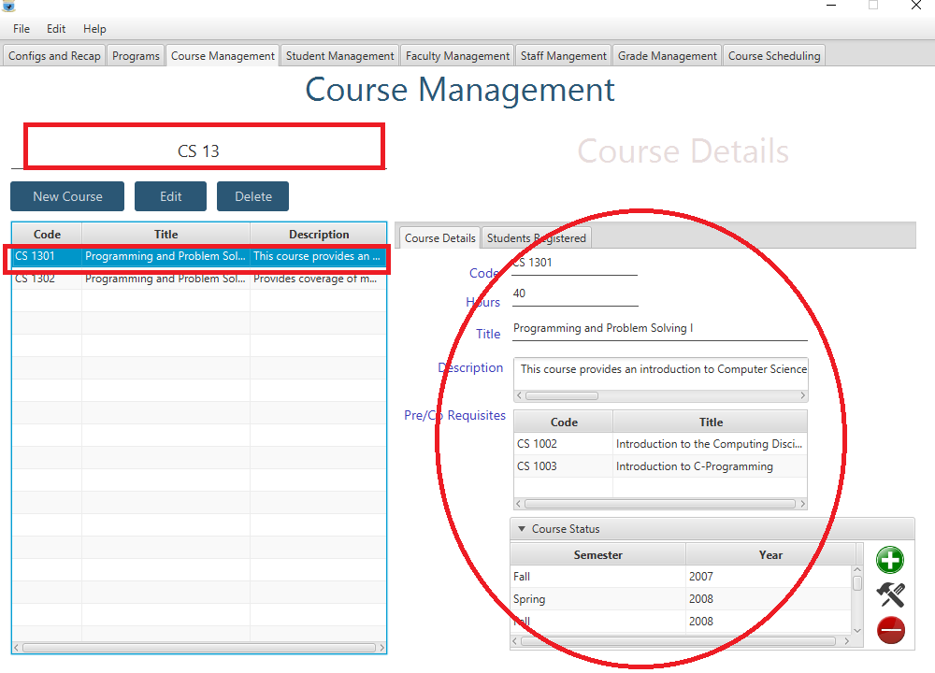

Figure 20: Course Details

### 3.3.3. Modify an existing course

This functionality allows an end user to modify the characteristics of a course. To complete this, proceed as follows:

* Search the course either by scrolling through the students table view or by typing the course cod, a course title or a part of it in the search zone;
* Click on the row representing that course and then on the button “edit” on top of the table view. Then the windows shown in figure 21 is displayed, the user modifies the course information and then click on the button “save” to save them or on the button cancel to cancel the modification;
* If no course is selected before clicking on “edit”, an error message is displayed.

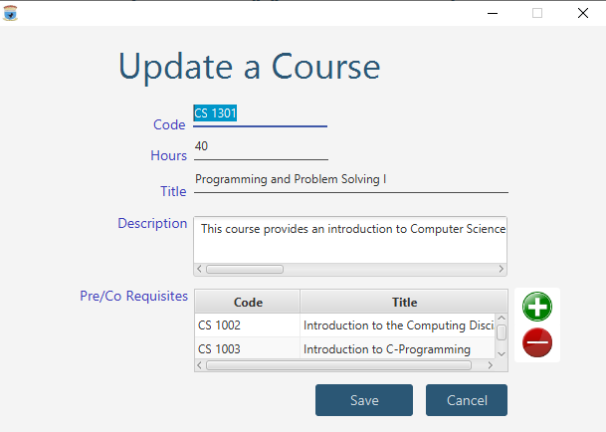

Figure 21: Update a Course

### 3.3.4. Opening and closing a course for a given semester

Courses are opened at the start of each semester and those opening can be later on modified. The interface to handle the openings is shown in figure 22, after the end used has selected the given course.

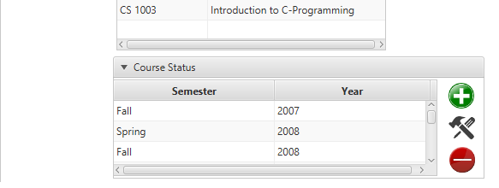

Figure 22: Course opening interface

To open a course a semester, the end user should click on the plus button to add a new opening. When done, the window shown in figure 33 displays the form to be filled and saved to create the new opening.

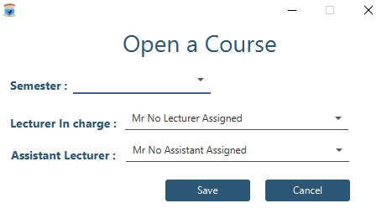

Figure 23: Open a Course

Select the semester, select the lecturer in charge of the course and the assistant if any and then click on “save” to save or on “cancel” to cancel the operation. This operation can take 10 to 20 seconds.

For a course opened, you can also change the parameters set. To do so, select the course and click the update button, the one between plus and minus. The window of figure 24 is opened. You change the information and you click on save to save the update.

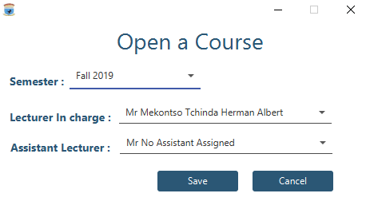

Figure 24: Update an Opening

In addition to these operations, you can also have the list of students registered to a given course a given semester.

## 3.4. Program Management

This module is to handle different programs offered by PKFokam Institute of Excellence. When you select the tab, it displays the window of figure 25.

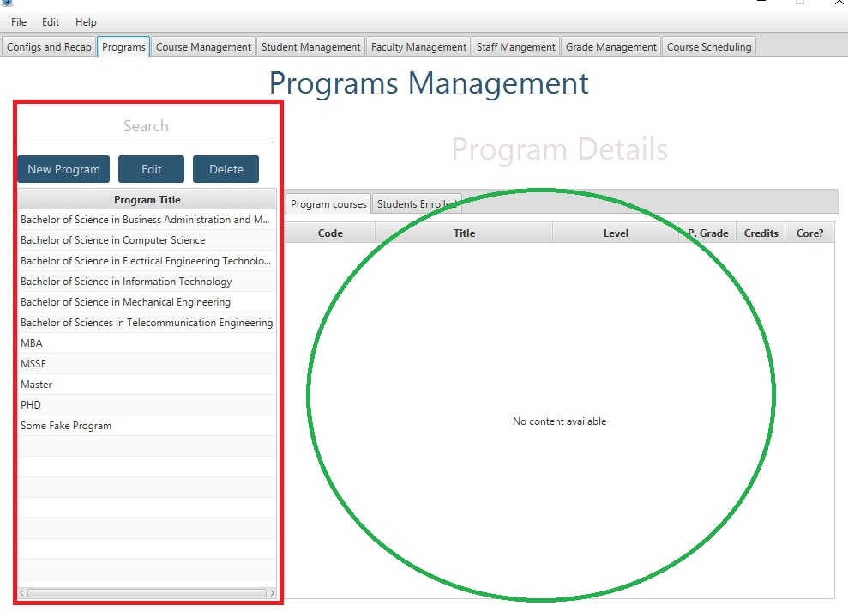

Figure 25: Home Programs Management

On the left panel you have the programs that are actually offered. On the right, you have details on those programs. The details include the list of courses in the program, and the list of students registered to the program any semester. To have those details, the end user just has to select the program by clicking on in from the table view. You can perform the following operations:

* Add and edit a program;
* Add, modify and remove a course in program.

### 3.4.1. Add or edit a program

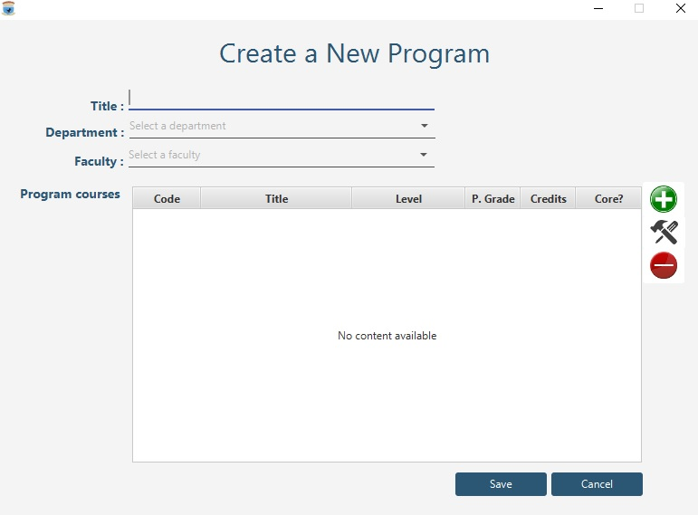

Figure 26: Add a new Program

To modify a program, select the program, then click on edit to edit the program to change its characteristics. That will open the existing program from which you can perform the other changes on a program as shown in figure 27.

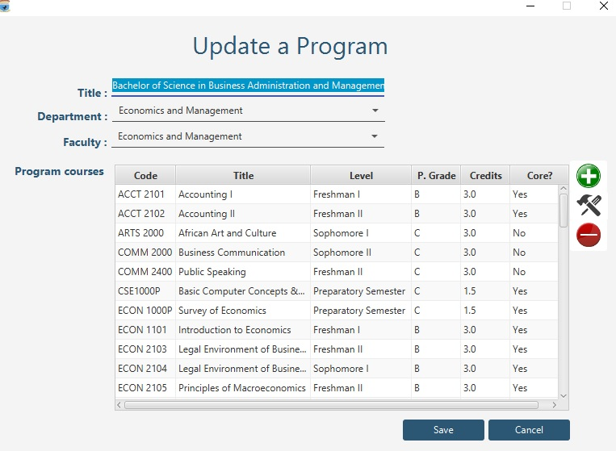

Figure 27: Update a program

Once you modify the program characteristics, you can click on the button “save” to save the changes and on the button “cancel” to cancel the update.

### 3.4.2. Add, modify and remove a course in program

You can add, modify or remove a course from a program using the three buttons on the right.

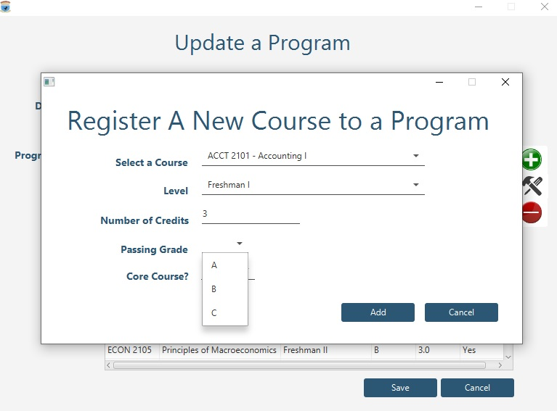

Figure 28: Add a Course to a Program

Click on the “plus” button to add a new course to a program. The following information have to be provided:

* The course;
* The level where the course is offered;
* The number of credits of a course;
* The passing grade;
* The type of the course: is it a core course or not.

Once these data are provided, click on “save” to save the operation or “cancel” to cancel the operation.

The end user can select a course from the program and click on the “minus” button to remove the course from the program course list.

To edit the info on the course added to the program, select the course and click on edit and the window of figure 29 will be displayed for you to modify the info.

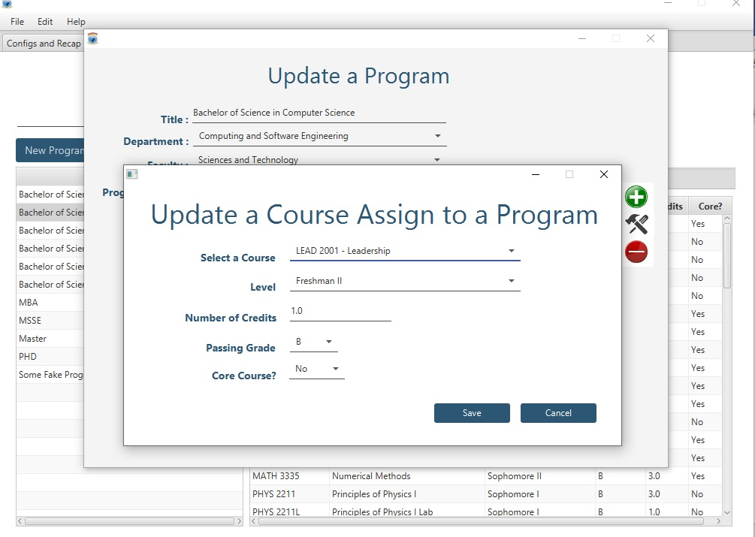

Figure 29: Update a Program Course

As shown in figure 29, the end user can modify the following information and then click on “save” to save the update:

* The level where the course is offered;
* The number of credits of a course;
* The passing grade;
* The type of the course: is it a core course or not.

## 3.5. Faculty Management

By faculty management here we mean the teaching staff management. When the end user clicks on the tab he gets the window in figure 30 specifying the list of lecturers actually registered for the University.

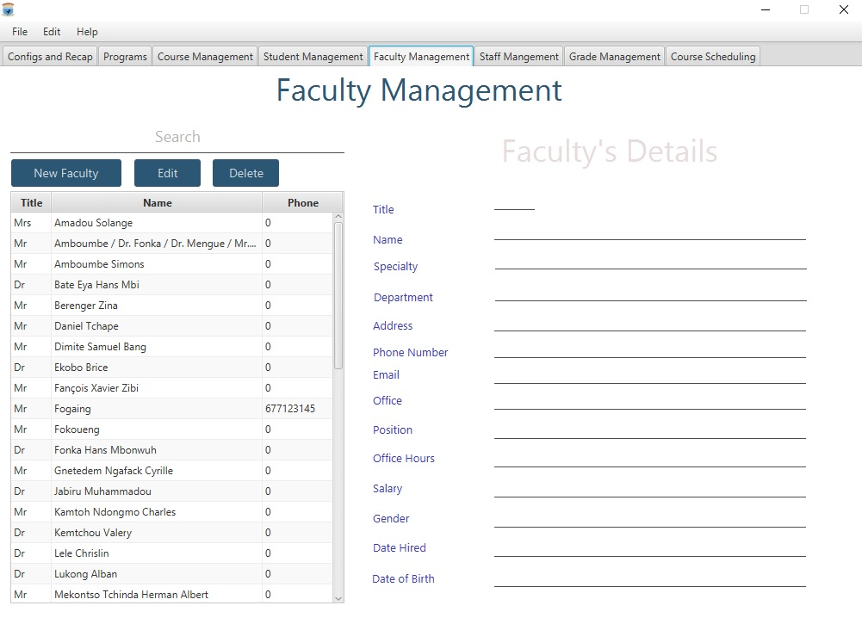

Figure 30: Faculty Management

To see the details on a faculty, click on the faculty and you get the details on the panel at the right as shown in figure 31.

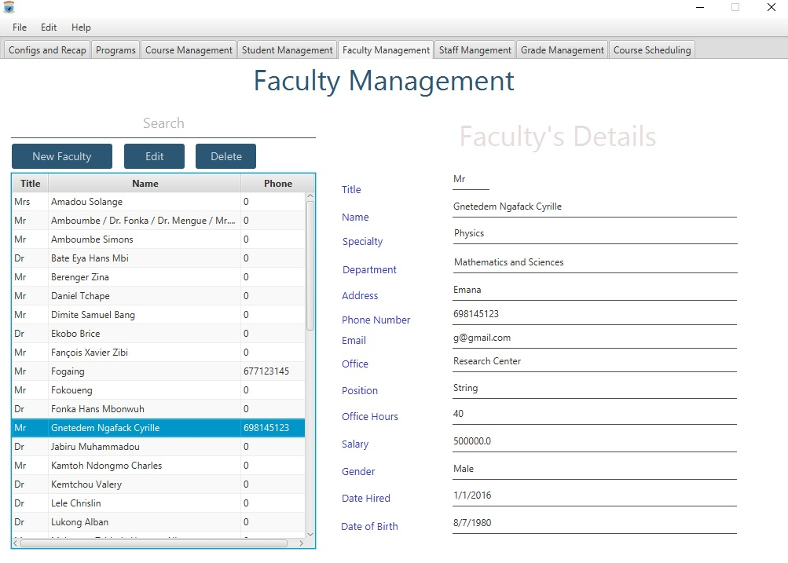

Figure 31: Faculty Details

The end user can then create or update a faculty the same way as it is done for a student.

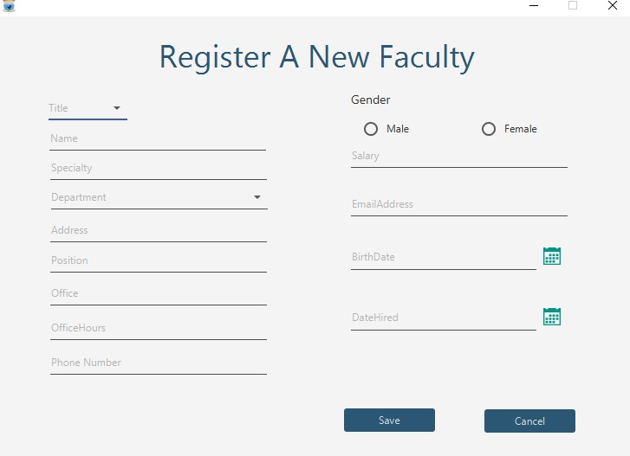

Figure 32: Create a new faculty

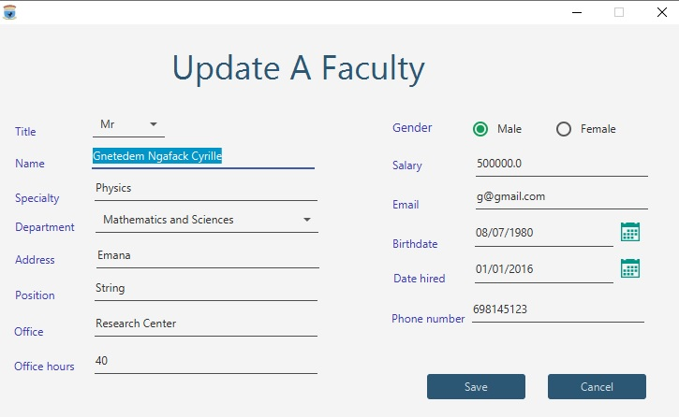

Figure 33: Update a Faculty

## 3.6. Staff Management

Staff management operations are very similar to those of faculty management. They include:

* Search and visualize the details on a staff
* Add or edit a staff.

Since there are the same, this many will just shows screen shots illustrating them.

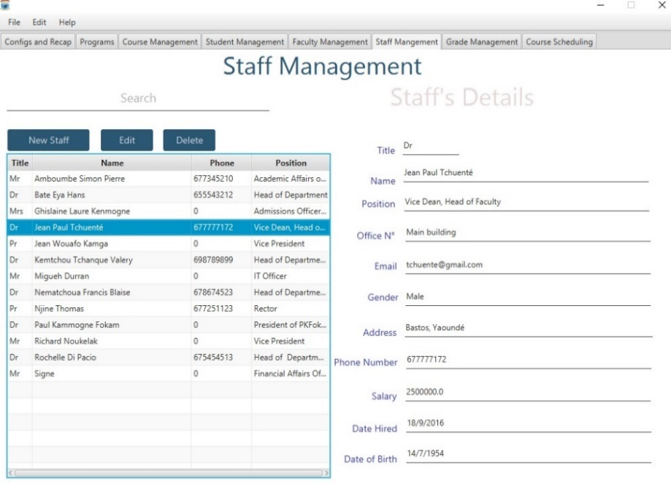

Figure 34: Search and display a Staff

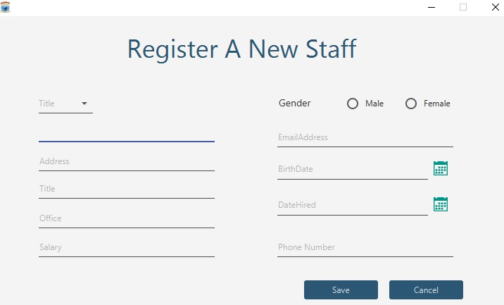

Figure 35: Create a new Staff

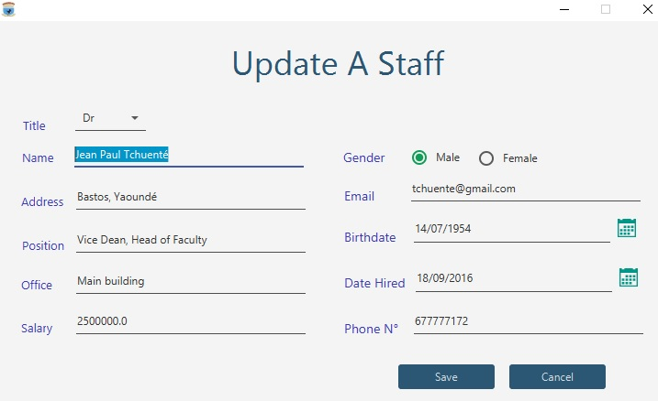

Figure 36: Update an existing staff

## 3.7. Grade Management

This module is used to search, register or modify student grades for any semester and any program. The end user can register end of semester final exams or any other evaluation grades (quizzes, tests, labs, assignment, research work, midterm, final exam). In any of these two cases, you should first select the grade management tab.

### 3.7.1. Registering or modifying end of semester final grades

Under the grade management tab, the end user selects the “Final Grade” tab. Next select the program, the semester and the course, and then click on “search” as shown in figure 37.

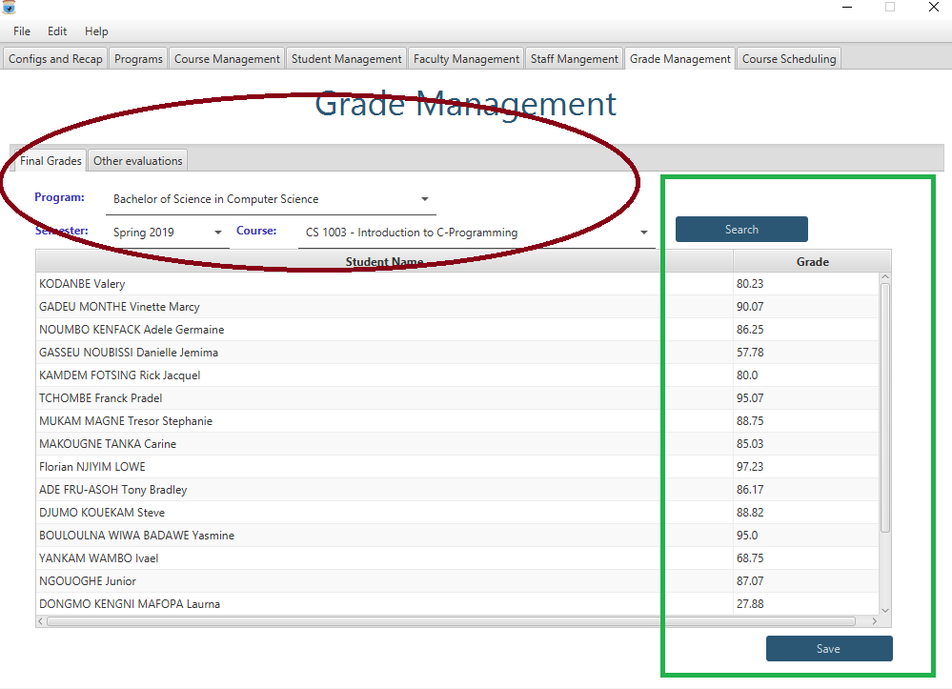

Figure 37: Final Grade Registration

The students are displayed along with their grades. If it is the first time, the grades will be set to their initial value with it is 0. The end user can then enter the student grades or modify the existing grades. After the operation is done, the end user has to click on the “Save” button to save all the changes performed otherwise, they will be discarded.

### 3.7.2. Handling the other grades

The end user can register any type of grades. The types of grades that can be registered or modified are:

* Quizzes;
* Assignments;
* Research work;
* Tests;
* Midterm exams;
* Lab;
* Final exam.

Figure 38 illustrates what should be done. You select a program, a semester, a course, the evaluation type and the evaluation date and the current date.

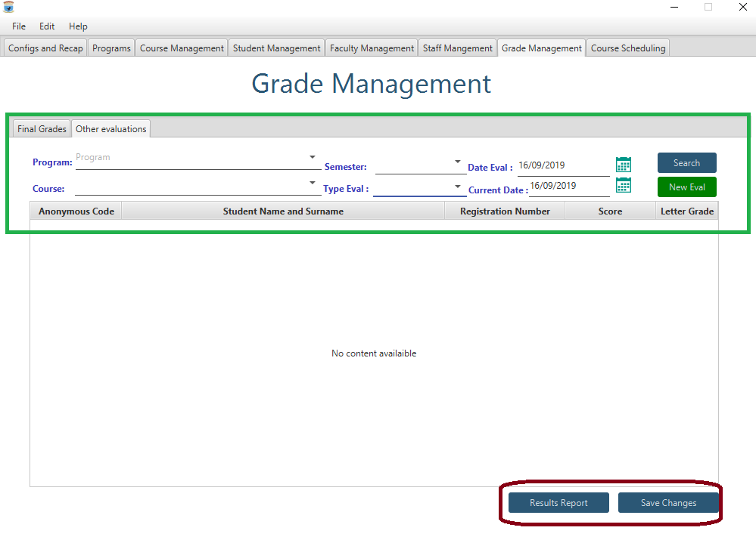

Figure 38: Other Grade Management

Click on “New Eval” to create a new evaluation, register the grades and save. You can also click on “Result Report”.

## 3.8. Course Scheduling

Click on the “Course Scheduling” tab and you get the image of figure 39.

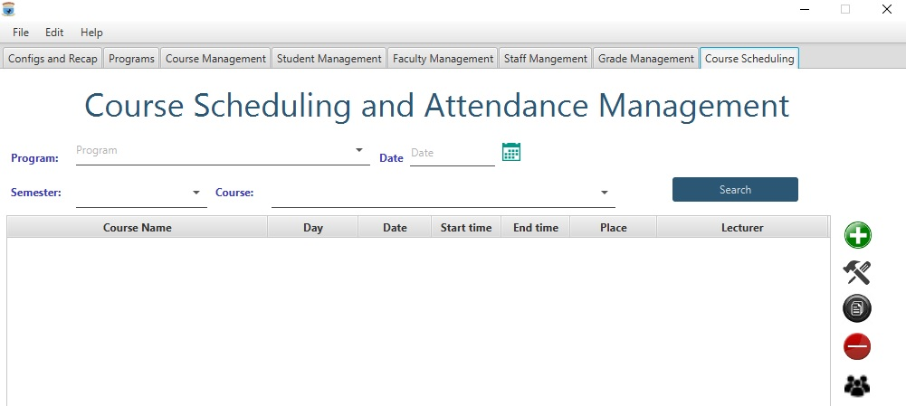

Figure 39: Attendance Management Home

From here, the end user can manage the schedules (create, update, duplicate, delete) and the attendances.

### 3.8.1. Create a new schedule

To create a new schedule, click on the button plus (+) at the right of the table view. This action will display a window shown in figure 40.

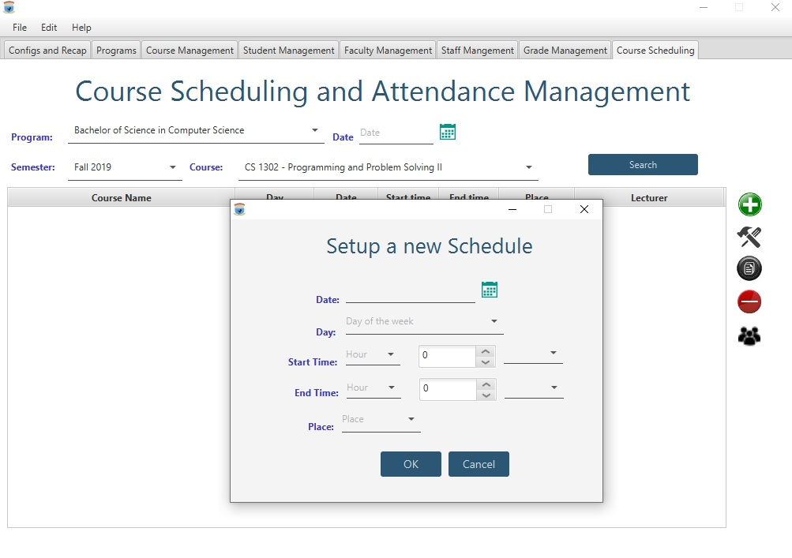

Figure 40: Create a new Schedule

The end user has to specify the program, the semester and the course for which the schedule is created.

### 3.8.2. Update a course schedule

To do this, the end user selects the course and the click on the update button at the right. The window displays figure 41 shows up. If no schedule is selected, an error message is displayed.

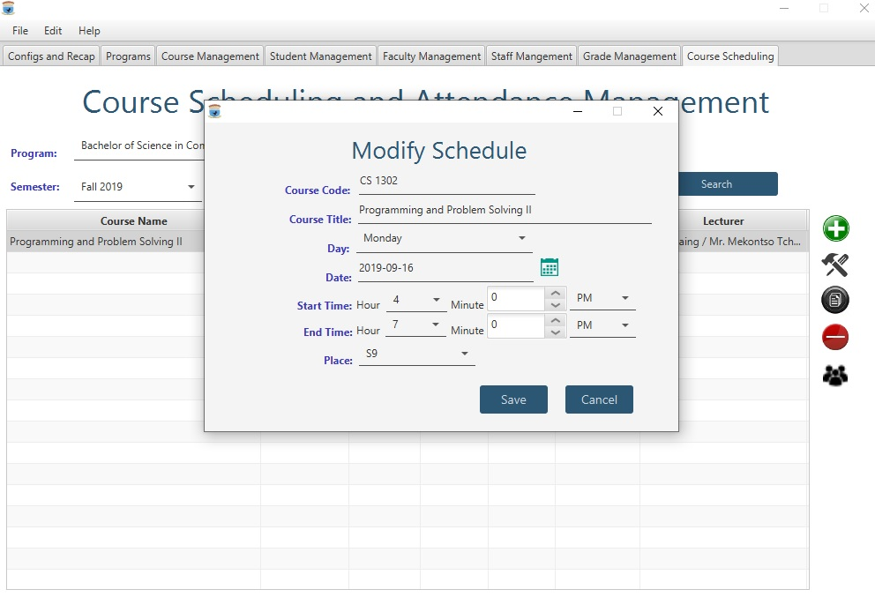

Figure 41: Update a Course Schedule

Once the modifications are performed, click on “Save” to confirm the modifications or on “Cancel” to cancel the update operation.

### 3.8.3. Duplicate a schedule

Duplicating a schedule is creating a new schedule from an existing one. The user clicks on the schedule to be duplicated and then on the duplicate button which is the third button on the right of the table view. The window displayed is very similar to the one for schedule update.

### 3.8.4. Mark Students Attendance

To mark students attendances, the end user should first research the course for which they wish to mark the attendance, by specifying de program, the semester, the course and optionally the search period as search criteria. Once the course is identified, the end user clicks on the course and on the attendance button which is the last button on the right of the attendance table view. This displays the window shown in figure 42.

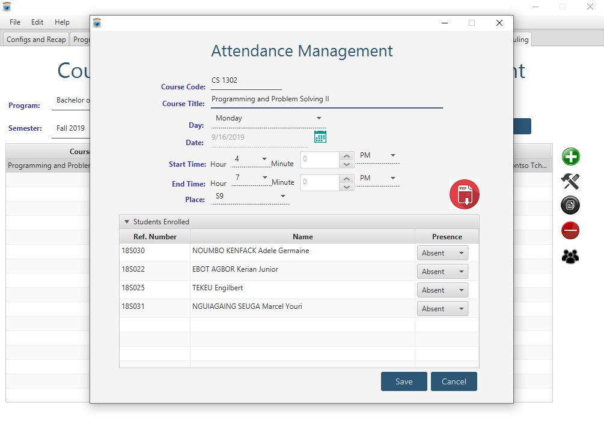

Figure 42: Marking Students Attendance

The end user can the mark the attendance of students or can print the attendance list.

Note that marking attendance is important to handle the students discipline. If the end user clicks on the attendance or the edit button without selecting a schedule, an error message will be displayed. The end user can choose to cancel the operation (or any other operation) they can just click on the cancel button, which will cancel the operation and close the corresponding window.

If the end user clicks on the print button, he or she will get the attendance list as show in figure 43.

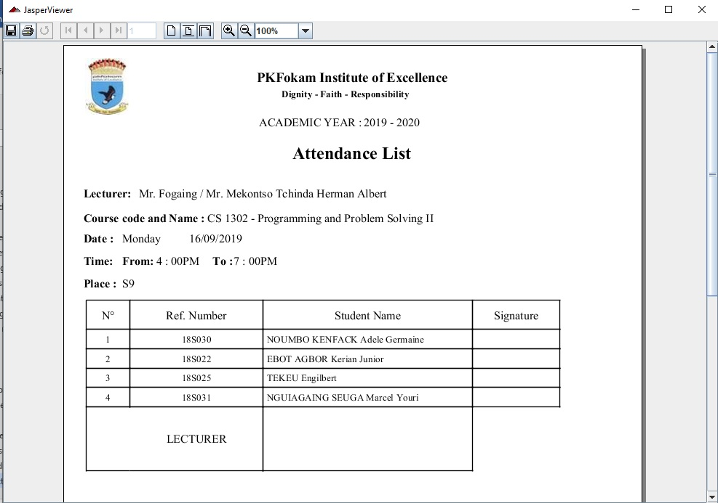

Figure 43: Attendance List Display

## 3.9. Administration and configuration of the Software

Administration tasks concern departments management and semester operations.

### 3.9.1 Department management

To perform department operations, first select the tab “Config and Recap” from the main window. The end user is displayed the window shown in figure 44.

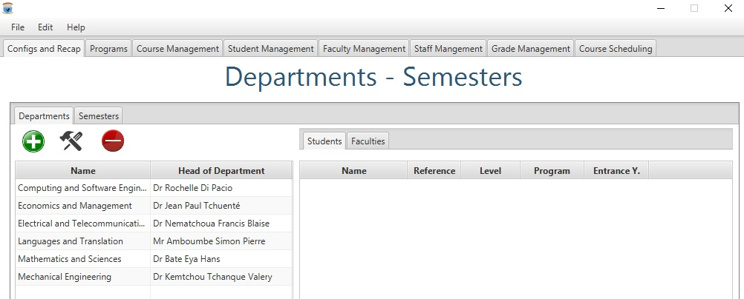

Figure 44: Configuration and Administration Tab

Department operations include: create a new department, update the information about an existing department, delete a department (but this is not activated because of its dangerous implications).

#### 3.9.1.a. Create a department

Under the Departments tab, click on the plus button. The window shown in figure 45 shows up. The end user should then enter the department name as well as the head of department. Once these data are provided, click on save to “save” the new department or in “cancel” to cancel the operation.

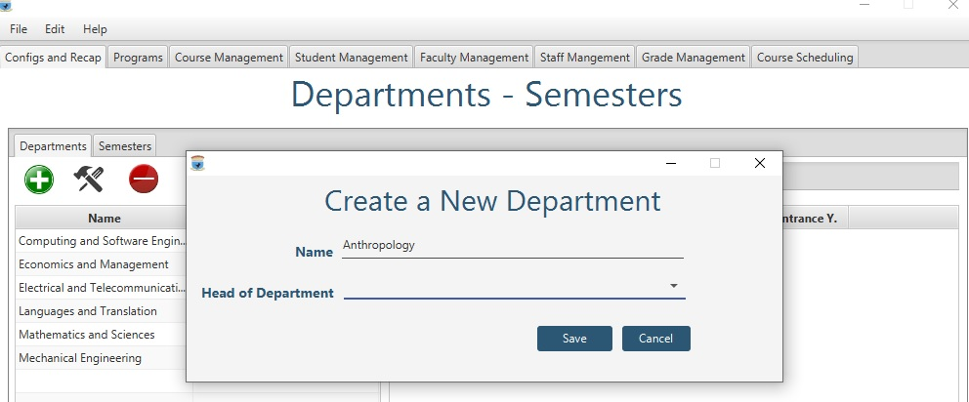

Figure 45: Create a New Department

#### 3.9.1.b. Update a department

To update an existing department, the end user selects the department from the department table view and then click on the “update” button, the one next to the “add” button. The end user should just then perform the changes and click on “save” to save the update. Figure 46 shows the update department window.

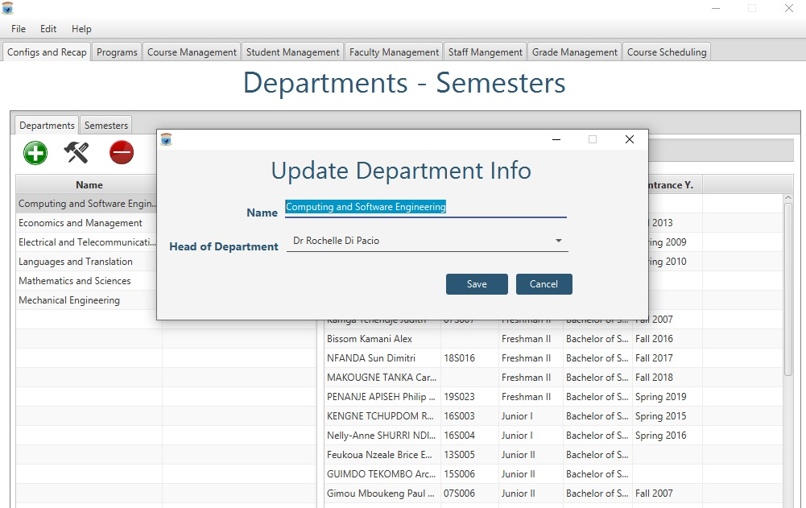

Figure 46: Modify an Existing Department

#### 3.9.1.c. Other operations on departments

In addition to adding and updating departments, the end user can also perform other tasks as getting the list of students in a department per level and per semester, as well as the faculties working in the department. This is illustrated by figure 47.

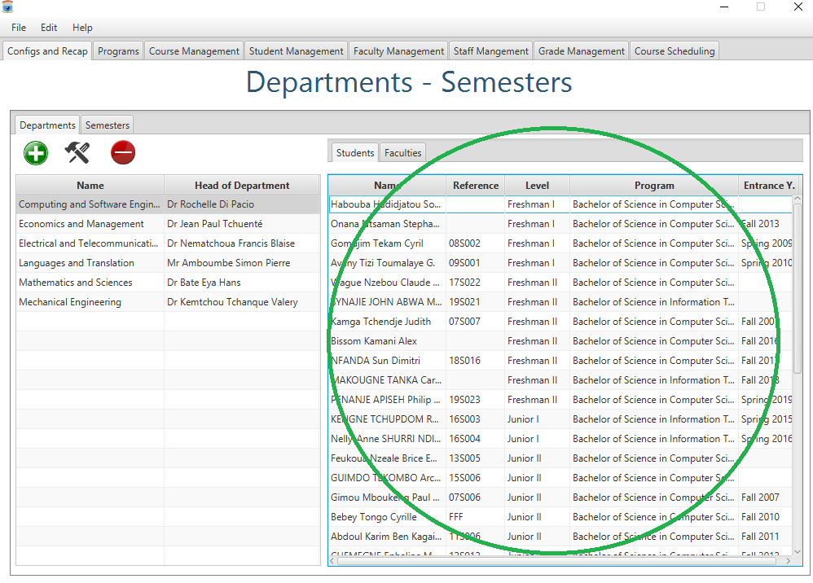

Figure 47: Other Operations on Departments

### 3.9.2. Semester Operations

The pre requisite to perform any semester operation is to select the semester. Semesters are displayed on the left panel of the “Semesters” tab as shown in figure 48.

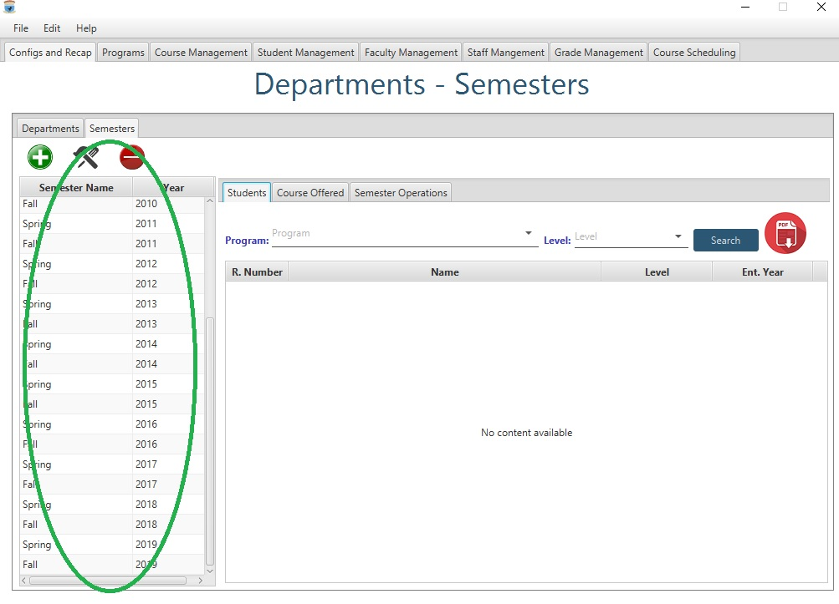

Figure 48: Selecting a Semester for End of Sem Operations

Semester operations include:

* Getting the students registered a given semester for a given program and or for a given level;
* Getting the list of course offered per program;
* Performing some end of semester and start of semester operations.

#### 3.9.2.a. Students registered a given semester

On the “Students” tab, you can get the list of students registered a given semester. You can filter the list by précising the program and or the level. You will get the window of figure 49.

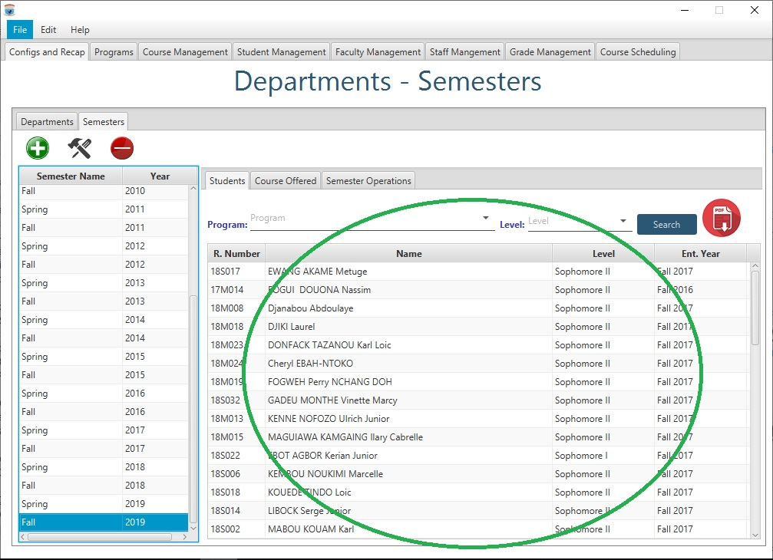

Figure 49: List of students of a Semester

The user can then click on the print button in red to print the displayed list as shown in figure 50.

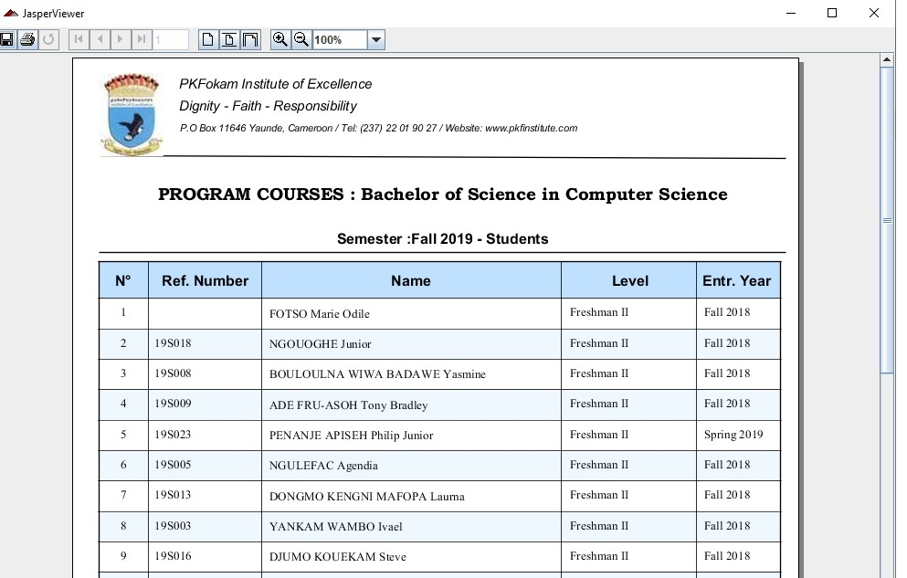

Figure 50: Print Student List per Semester

#### 3.9.2.b. Courses offered in a semester

The end user can also get the list of courses offered a given semester per program as shown in figure 51.

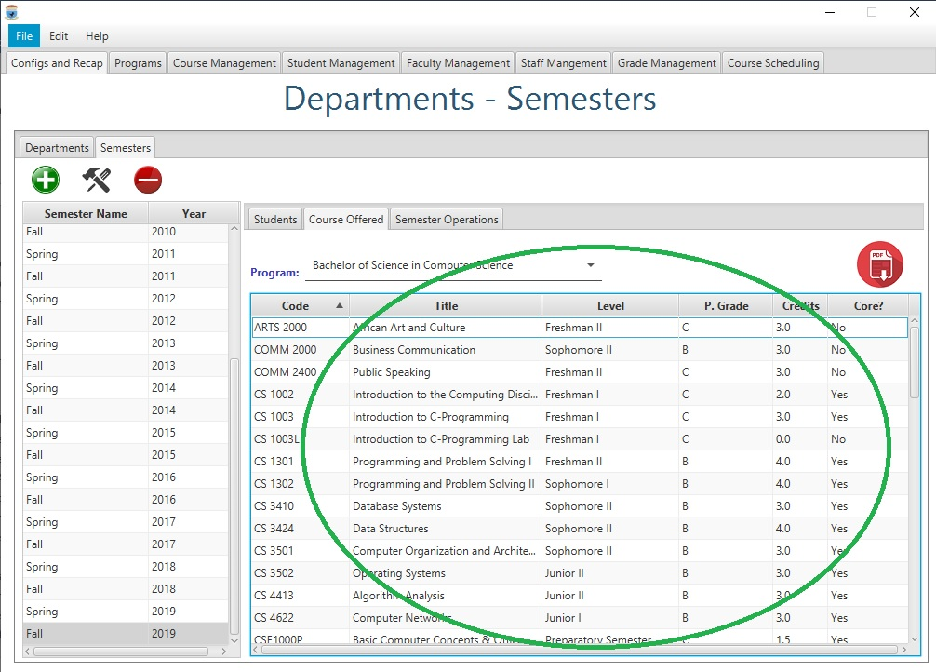

Figure 51: Getting the list of courses offered for a given program

The end user can print the list by clicking on the print button (the button in red) as shown in figure 52.

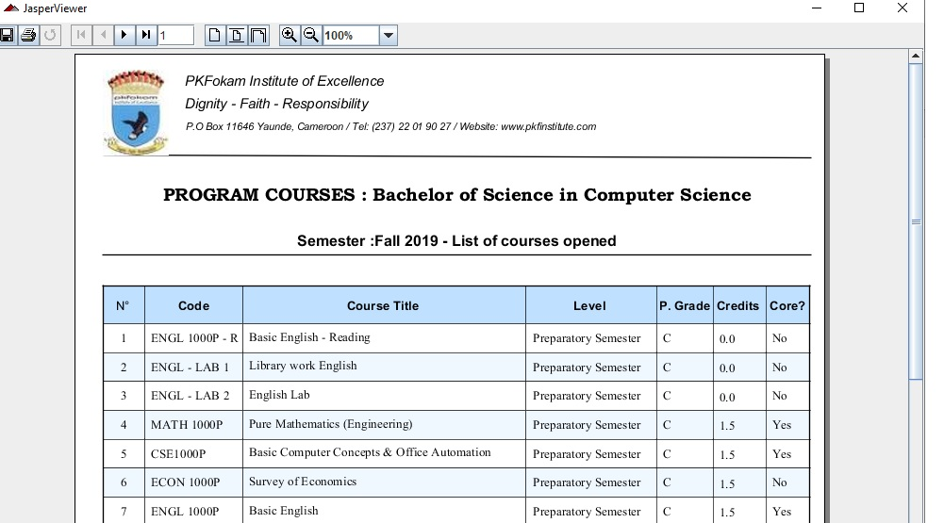

Figure 52: Printing the list of Courses Opened a Given Semester for a Given Program

#### 3.9.2.c. End of semester operations

End of semester operations include:

* Closing and opening semesters (this can only be done by the system administrator);
* Modifying the maximum number of credits, a student can take in a semester;
* generating the consolidated grades for jury at the end of the semester.

These operations can be carried out from the window shown on figure 53.

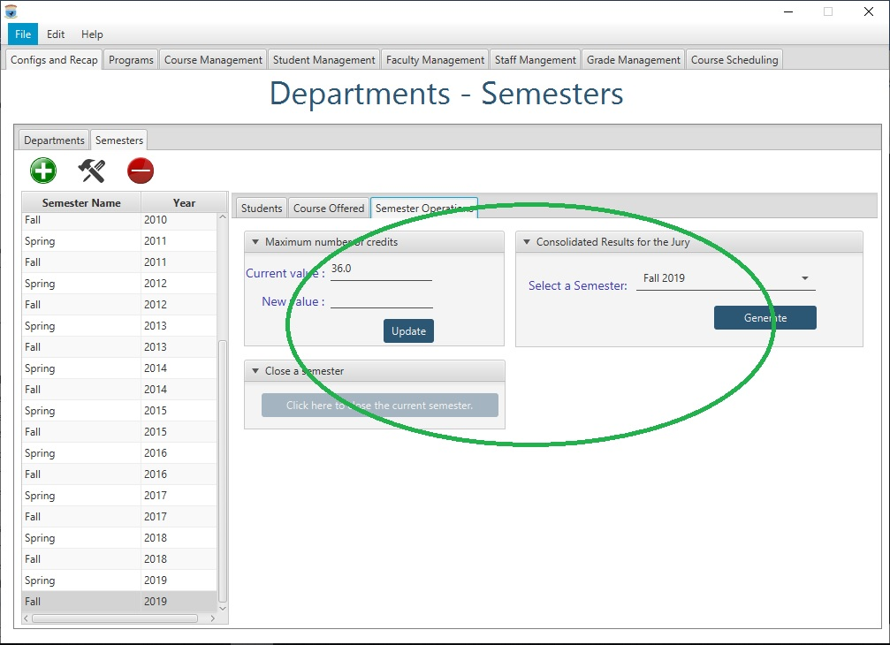

Figure 53: Start and End of Semester Operations

The end user can eventually generate final results for the jury. The result generated will be similar to the one of figure 54. The end user just hast to specify the semester.

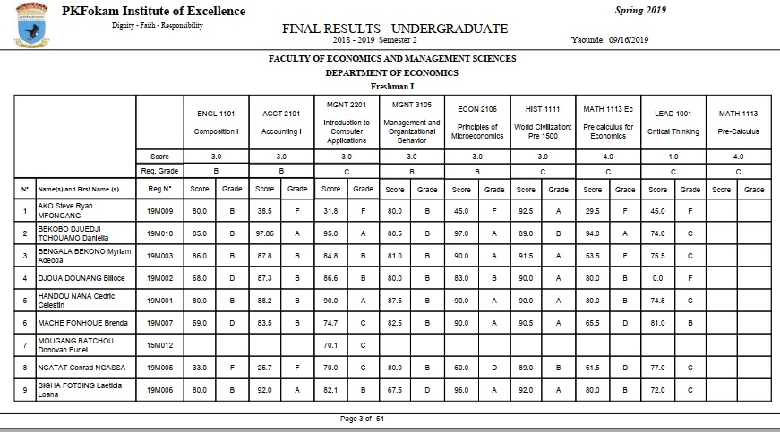

Figure 54: Jury Results Generation